The Journey
Introduction:
Every project is a metaphorical journey involving meeting challenges, delivering results, leadership skills, problem solving, resource management and team work to name but a few! The Journey is a metaphorical project which examines and explores all these elements in a controlled, ‘safe’ microcosm.
Who needs it?
- New project or management teams
- People who want to learn about their (and their colleagues’) leadership styles and qualities
- Teams who are having communications issues
- People interested in how they maximise their contribution to their teams and want to understand more about the roles they play in their success (or otherwise!)
Overview:
The Journey is a facilitated, outdoors experience, which provides a series of situations and tasks for both team and individuals to learn about:-
- Their communications skills
- Their motivation
- Leadership and followership skills
- Their Team roles & styles
- What strategies work
And create a new environment and shared language for resolving & preventing misunderstandings.
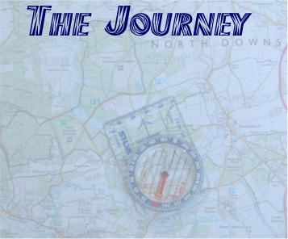
If you are wondering if you can afford it, a better question might be, can you afford to have your project late, or over-budget, or a key team sub-optimised?

“A journey of 1,000 miles begins with the first step.” Are you ready to take yours?
http://www.i-change.biz/journey.htm

